Asimov, Bradbury, Clark, Technology, Houghton Mifflin First Edition, First Print 1989. No dust jacket. Fine softcover with all 85 pages tightly bound and no marks of any kind. ISBN 0395459958
ID 000375 Price $15 Box 9

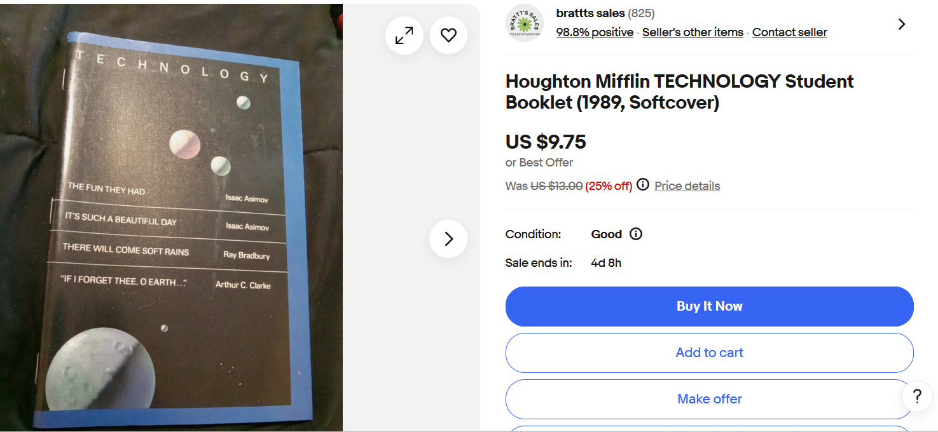
Ebay
BookFinder

